

**Year 12 Integrated Science 2020**

**Task 1: Extended Response - Wetlands in Western Australia**

**Background Information**

Wetlands are vital for human survival. They are among the world’s most productive environments; cradles of biological diversity that provide the water and productivity upon which countless species of plants and animals depend for survival.

Wetlands are indispensable for the countless benefits or “ecosystem services” that they provide humanity, ranging from freshwater supply, food and building materials, and biodiversity, to flood control, groundwater recharge, and climate change mitigation.

Yet study after study demonstrates that wetland area and quality continue to decline in most regions of the world. As a result, the ecosystem services that wetlands provide to people are compromised.

Western Australia’s unique and diverse wetlands are rich in ecological and cultural values and form an integral part of the natural environment of the state.

**Task**

You are tasked with completing a research assignment on a significant wetland from Western Australia. The assignment involves:

* a set of research notes (see below for specifics)
* A 5 min presentation (powerpoint, video, poster, other) that outlines the key information from your research.

You need to choose one of the following wetlands (no more than 2 students can do each wetland).

* Becher Point Wetland
* Forrestdale and Thomson lakes
* Lake Gore
* Muir-Byenup System
* Ord River floodplain
* Roebuck Bay
* Lake Toolibin
* Vasse-Wonnerup System
* Peel-Yalgorup System
* Lake Warden
* Lake Argyle and Kununurra

**Key Dates**

Research Notes: Mon 10th – Thurs 13th Feb (3 lessons)

In-class presentation: Thurs 20th Feb 2020

**Task Weighting**

15% of the year mark.

**Total marks available**

60 marks

**Part 1: Research Notes [39 marks]**

You are required to research the answers for the following questions.

Your notes need to be:

* Written in your own words. ANY SECTIONS THAT ARE PLAGIARISED WILL NOT BE MARKED.
* Concise, using dot points where applicable.
* Correctly referenced (in-text and bibliography).

Your research notes **WILL** need to be submitted to your teacher at the beginning of the lesson of the final presentation.

**Useful resources**

<https://www.dpaw.wa.gov.au/management/wetlands>

<https://www.environment.gov.au/water/wetlands/ramsar/criteria-identifying-wetlands>

<https://www.environment.gov.au/water/wetlands/australian-wetlands-database/australian-ramsar-wetlands>

**Part 2: Presentation [21 marks]**

With the information you have collected through your research, produce a 5-minute presentation that will engage the viewer (your fellow peers). Your presentation must include all key information from your research. You can choose any presentation type you think applicable to present this information.

|  |  |  |  |
| --- | --- | --- | --- |
| **Description** | **3 marks** | **2 marks** | **1 mark** |
| Presentation of content   * PowerPoint * Video * Online website * Poster | 8-10 slides/sections included with key ideas linked to images and sources of information referenced. | **8-10 slides/sections included that shows organisation of ideas in each of the researched content areas.** | 7 slides/sections included that is mainly text. |
| Content | Shows a full understanding of the topic | **Shows a good understanding of the topic** | Shows some understanding of the topic |
| Use of headings and sub-headings | **All headings and subheadings used.** | Some headings and subheadings used. | Some headings used |
| Delivery | **Speaks with fluctuation in volume and inflection to emphasize key points.** | Speaks with satisfactory variation of volume and inflection. | Speaks in uneven volume with little or no inflection. |
| Creativity | Creative use of fonts, transitions or animation function that includes a short-embedded clip/s that have been produced by the student | Some attempt to use transitions or animation functions on PowerPoint. | **Some relevant images used and an attempt made to use colour, smart art or different fonts.** |
| Audience interest | Engaging and interesting all the way through. | **Captured interest reasonably well.** | Relevant information is included. |
| Engagement | High level of effort. | **Satisfactory level of effort.** | Little effort shown. |
| **Total** | **/21** | | |

**Marking Guide**

|  |  |  |
| --- | --- | --- |
|  | **Item Description** | **Marks** |
| Research Notes | 1. *Wetland description*   Clearly define what constitutes a wetland  Outline the different types of wetlands and what makes them important. | **1**/2 |
| 1. *Ramsar Convention*   Correctly define what the Ramsar Convention is and clarify why is it important? | **2**/2 |
| 1. *Justification*   Identify which Ramsar Criteria your WA wetland qualifies for.  Clearly explain using multiple points how your WA wetlands meets this Ramsar Criteria. | **4**/4 |
| 1. *Map*   Provide a map of your WA wetland site (include geographical coordinates and location of nearest town or major town/city).  Ensure that you clearly delineate the various types of wetlands within your site. | **3**/4 |
| 1. *Key Features*   Analyse and describe the key features of your WA wetland site (biogeography, physical conditions, hydrological values, wetland type). | **5**/8 |
| 1. *Fishbone*   Use the Fishbone Template to classify noteworthy biotic factors (flora and fauna) that inhabit your WA wetland.  For each, describe what makes each one noteworthy. | **0**/6 |
| 1. *Social/Cultural Values*   Describe if the site has any social and/ or cultural values and detail what makes them important. | **0**/4 |
| 1. *Ecological Condition of your WA wetland*   Analyse how current land and water use activities within the Ramsar site and surrounding catchment are affecting the ecological character of your WA wetland. | **3**/6 |
| 1. *Referencing*   Include in-text referencing and provide a bibliography. | **2**/3 |
| **Research Notes Sub Total** | | **20/39** |
| Presentation | Presentation of content | **2**/3 |
| Content in presentation | **2**/3 |
| Use of headings | **3**/3 |
| Delivery | **3**/3 |
| Creativity | **1**/3 |
| Audience interest | **2**/3 |
| Engagement | **2**/3 |
| **Presentation Sub Total** | | **15/21** |
| **TOTAL** | | **35/60** |

**Part 1: Research Notes**

1. Wetland description (Define what constitutes a wetland and describe the different types of wetlands and what makes them important). **1 mark** (2 marks)

A wetland is an area of land that has been flooded that has an ecosystem based on hydric soils and vegetation that has adapted to living in water-saturated soils. There are several different types of wetlands with some of these being sumplands, damplands and playas.

1. Describe what the Ramsar Convention is and clarify why it is important. **(2 marks)**

The ramsar convention is an international treaty signed in 1971 that aims to conserve wetlands as well as the resources found within them. It is important because wetlands are beneficial to the earth as they provide freshwater, food and building resources as well as flood control and reduces the effect climate change has.

1. Identify which Ramsar Criteria your WA wetland qualifies for. **(1 mark)**

Lake Toolibin qualifies for 4 criteria:

Criteria 1: contains a representative, rare, or unique example of a natural or near-natural wetland type found within the appropriate biogeographic region

Criteria 2: supports vulnerable, endangered, or critically endangered species or threatened ecological communities

Criteria 3: supports populations of plant and/or animal species important for maintaining the biological diversity of a particular biogeographic region.

Criteria 4: supports plant and/or animal species at a critical stage in their life cycles, or provides refuge during adverse conditions.

1. Clearly explain using multiple points how your WA wetlands meets this Ramsar Criteria. **(3 marks)**

Criteria 1: Lake Toolibin is the last large Casuarina obesa (swamp oak) dominated wetland located in south-western Australia. They were formally widespread but have decreased from degradation due to salinity.

Criteria 2: The ecological community in Lake Toolibin are perched wetlands of the wheatbelt region with extensive stands of living swamp oak and paperbark across the lake floor. This ecological community is listed as a national threatened ecological community under the EPBC Act.

Criteria 3: Due to the lake being the last substantial remnant of a formerly common wetland type in the South-West Coast Australian Drainage Division, it’s important to maintaining the genetic and ecological diversity of the inland agricultural area of south-western Australia.

Criteria 4: When full, or close to full, Lake Toolibin supports one of, if not, the largest amount of breeding waterbird species in all out south-western Australia

1. 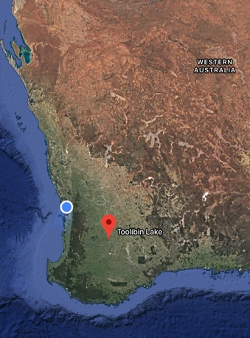Provide a map of your WA wetland site (include geographical coordinates and location of nearest town or major town/city). Ensure that you clearly delineate the various types of wetlands within your site.

(4 marks) **You need to show the different types of wetlands as well. 3 marks**

Coordinates: 32.9189° S, 117.6067° E

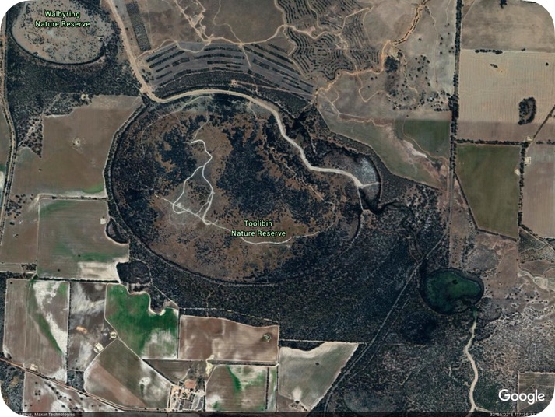The nearest major town is Bunbury

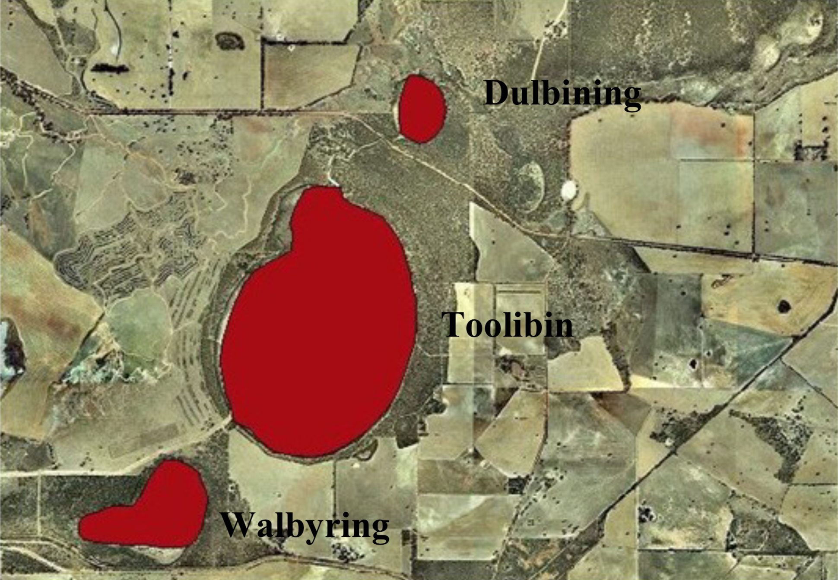

1. Analyse and describe the key features of your WA wetland site, include the following: biogeography, physical conditions (including climate data), hydrological values, wetland type. (8 marks)

Lake Toolibin is a seasonal, freshwater wetland, meaning that it will only have water in it during certain seasons, that is about 300 hectares (740 acres) in size. The lake is surrounded by woodlands of water tolerant tree species. It gets a rough average of 400 mm of rainfall with an average of 1800 mm of evaporation annually. This means that the lakes will sometimes dry out for several years, however, if there is a large amount of rainfall in a year the lake will often hold the water for several years. The only inflow comes from local surface runoff but outflows to the surrounding wetlands.

**5 marks**

**What is the average annual temperature, the hydrological values?**

1. Use the Fishbone Template to classify noteworthy biotic factors (flora and fauna) that inhabit your WA wetland. For each, describe what makes each one noteworthy. (6 marks)

**0 marks**

1. Describe if the site has any social and/ or cultural values and detail what makes them important. (4 marks)

I was unable to find any cultural or social values surrounding the lake

**0 marks- social can also be how it is used.**

1. Analyse how current land and water use activities within your site and the surrounding catchment are affecting the ecological character of your WA wetland. (6 marks)

The main use of land in the Toolibin catchment is dry-land agriculture to produce wool and cereal grain, conservation of the lake has lead to reduced waterlogging in the surrounding areas and farmland that is caused by the overflowing that can occur. This allowing flora to survive for longer durations of time giving the fauna more access to food sources such as bugs that thrive in the flora.

**3 marks**

**Great, however what else can you provide in regards to fertilisers that are used and then seep into the lake?**

1. Bibliography (Referencing) (3 marks) **where are your in-text references? 2 marks**

<https://www.ramsar.org/about/the-importance-of-wetlands>

<https://www.dpaw.wa.gov.au/images/documents/conservation-management/wetlands/ramsar/ECD_Toolibin_Lake.pdf>

<https://en.wikipedia.org/wiki/Toolibin_Lake>

<http://www.environment.gov.au/biodiversity/threatened/conservation-advices/perched-wetlands-wheatbelt-region>

<https://www.environment.gov.au/water/wetlands/australian-wetlands-database/australian-ramsar-wetlands>

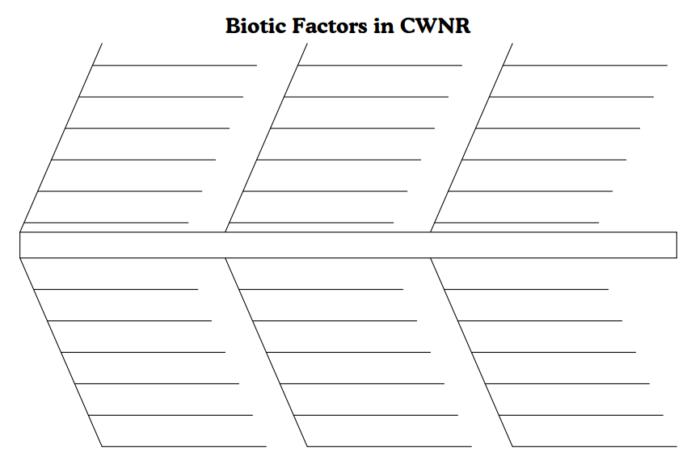<https://www.environment.gov.au/water/wetlands/ramsar/criteria-identifying-wetlands>